MAMCD Spring (Virtual) Conference
“Multicultural Considerations for Supporting Diverse Clients”

DATE: April 17th 2021 TIME: 9:00am-4:00pm

Conference description:
MAMCD’s Spring 2021 virtual conference aims to offer attendees space to expand their knowledge, skills, and resources related to best supporting diverse youth, students, clients, colleagues, and communities. Presenters will share relevant literature, related research, strategies and interventions, advocacy efforts, multicultural considerations, and implications for counselors and/or counselor educators. Space will be provided for discussion, questions, and gathering resources.

Conference learning objectives:
- State the experiences of diverse clients in a range of settings.
- Articulate ways to advocate for diverse clients in various settings.
- State and describe both strategies and supportive resources that can aid in the success of diverse clients.

Conference sessions learning objectives & presenter credentials

Session #1 - “Resiliency & Layers in the Storm: The Physical & Psychological Effects of COVID-19 among African Americans”

Attendees will learn to: (1) discuss the physical and psychological effects of COVID-19 among African Americans, (2) understand how medical mistrust, lack of access to healthcare and racial stigma and other barriers has led to African Americans ineffectively managing pre-existing health conditions that could have prevented COVID, and (3) review and discuss effective coping strategies & protective factors to manage anxiety and build resiliency and hope in clients amidst COVID-19.

Kizzy Pittrell, Ed.D., LCPC, ACS

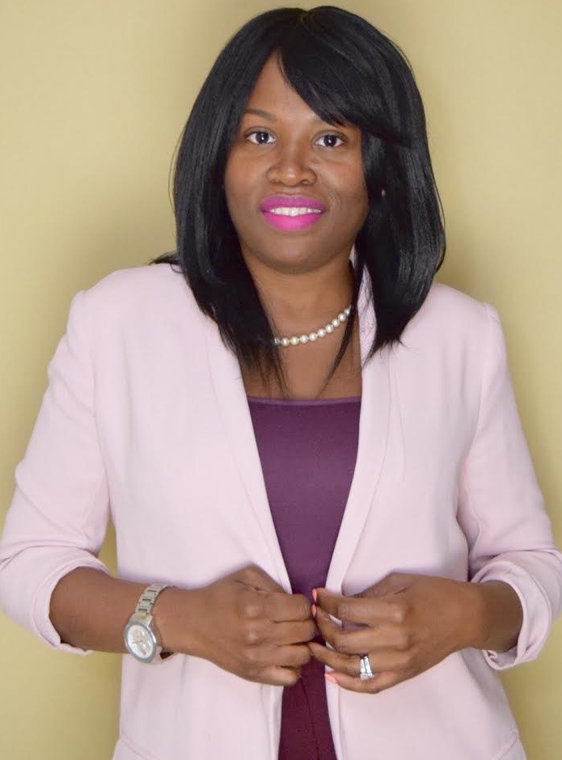
Dr. Kizzy Pittrell, Ed.D. is a graduate of Argosy University, Washington DC from the Counseling Psychology program. Dr. Pittrell received her Masters of Counseling from Towson University and Bachelors of Science in Psychology from Bowie State University.
Dr. Pittrell is a Licensed Professional Counselor, an Approved Drug and Alcohol counselor, a Master Addiction Counselor, and an Approved Clinical Supervisor in Maryland. Dr. Pittrell has worked in the community sector providing mental health and addiction counseling and treatment to adults and adolescents for 15 years. Currently, Dr. Pittrell is owner of Ross Counseling, a private practice providing therapy to individuals, families and couples and manages a community mental health facility in Baltimore. More recently, Dr. Pittrell along with her husband opened a psychiatric rehabilitation program in Baltimore county called Strengthening Families Building Communities. In addition, Dr. Pittrell has conducted several discussions and trainings related to grief, trauma, COVID, and effective ways to cope with mental illness. Dr. Pittrell is passionate about educating the community about mental health and reducing the stigma of mental health. In her spare time Dr. Pittrell loves blogging, spending time with family, reading and she is certified Zumba instructor. She is also an author of a children’s book about maternal depression.

Session #2 - “Walking the Walk of Antiracist Counseling Practice with BIPOC Youth”

Attendees will learn to: (1) explore the intersecting contextual realities that BIPOC youth face in a post pandemic world, (2) understand the need for counselors to develop a personal and professional anti-racist identity in order to competently serve BIPOC youth and communities, and (3) investigate implications of antiracist practices in terms of barriers to systemic change and sustainability.

Ileana A. Gonzalez, Ph.D.
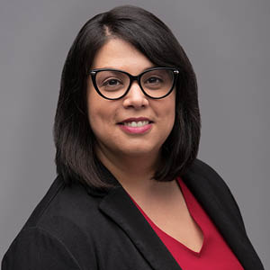
Dr. Gonzalez is a child of immigrants and a first-generation college student. She is currently an Assistant Professor in the Counseling program at Johns Hopkins University in Baltimore, Maryland. She received her doctorate in Counselor Education from the University of Maryland, College Park, and her M.Ed. in School Counseling at the University of Florida. She has published and presented nationally on social justice action in schools and higher education settings. She previously served as the Chapter faculty advisor for the Johns Hopkins University Lambda Chapter of CSI and was recently awarded the 2020 Counselor Educator of the year by the Maryland School Counseling Association (MSCA). Her research interests include urban school counselor preparation, multicultural and antiracist counselor education and cultural competence in counseling.

Session #3 - “Supporting Women of Color Enrolled in Counseling Programs at PWIs”

Attendees will learn to: (1). identify and describe the factors that shape the experiences of women of color enrolled in counseling programs at PWIs, (2). describe how these factors shape professional identity development, academic performance, social interactions, and overall well-being of women of color enrolled in counseling programs at PWIs, and (3). state strategies that may serve as supportive resources for women of color enrolled in counseling programs at PWIs.

Atiya R. Smith, Ph.D., LCPC, NCC, CATP
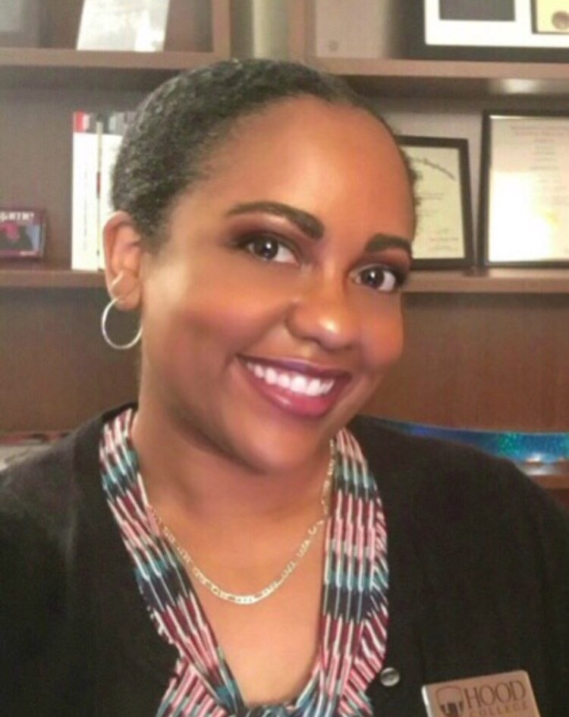
Dr. Atiya R. Smith is an assistant professor in the Department of Psychology & Counseling at Hood College in Frederick, Maryland. She is a Licensed Clinical Professional Counselor in the state of Maryland, a National Certified Counselor, and a certified Child and Adolescent Trauma Professional. Dr. Smith received a bachelor’s degree in Psychology from Hood College, a master’s degree in Applied Psychology: Counseling Track from the University of Baltimore, and a doctoral degree in Education with a specialty in Counseling & Counselor Education from the University of Rochester. Dr. Smith is the current president of the Maryland chapter of the Association of Multicultural Counseling and Development (MAMCD). She also holds the position of Vice Chair for Scholarship & Research for the Commission for Academic Support in Higher Education (CASHE) in the American College Personnel Association (ACPA) and is the Co-Chair of the Mentoring Work Group with the Association for Counselor Education and Supervision’s School Counseling Interest Network (ACES SCIN). At Hood College, she serves as the faculty advisor to the Black Student Union, coordinates the school counseling specialty within the Counseling Master’s Program, founded and advises the Chi Sigma Iota (CSI) chapter, and is the founder of the Graduate Students of Color Alliance. Within ACES, she was selected as an ACES Presidential Fellow (2013), an ACES Emerging Leaders Fellow (2013), and an ACES Emerging Leaders Mentor (2019). She has been inducted into the international honor societies for counseling (Chi Sigma Iota), psychology (Psi Chi), and education (Kappa Delta Pi). Dr. Smith’s counseling experience includes work in P-12 settings (both public and independent schools), university counseling centers, a pediatric hospital, and outpatient clinics. Her professional experience includes providing executive functioning coaching, academic coaching, and additional support to children, adolescents, and college students with Autism Spectrum Disorder, ADHD, Specific Learning Disabilities, and Traumatic Brain Injuries. Dr. Smith’s research interests focus on the experiences of girls and women of color attending PWIs, first year college students/students in transition, and students with disabilities. She also has an interest in race-based traumatic stress, anxiety disorders, the mind-body connection, ambiguous loss, school counseling supervision, and professional identity development in graduate students enrolled in counseling programs.

Laura Fernandez, M.S., LGPC, NCC

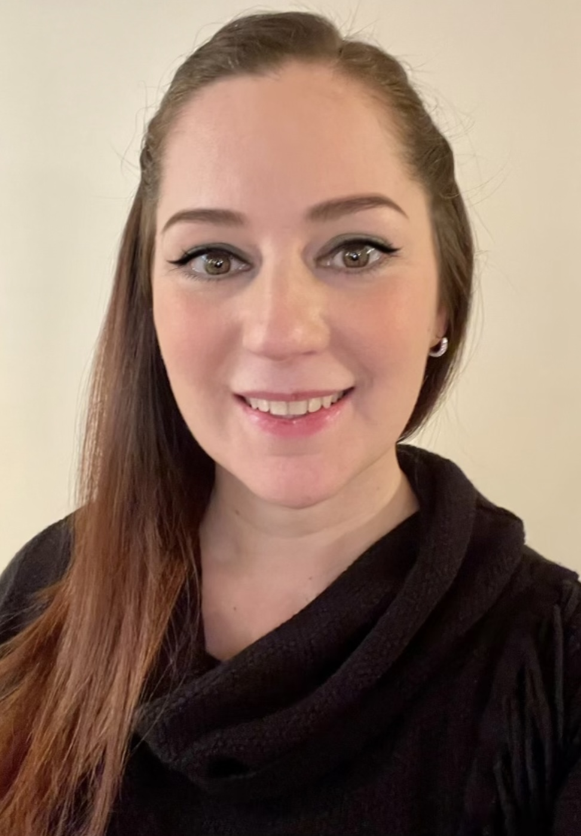
Laura Fernandez is a school therapist at the Laurel Hall School – a non-public Type I school program through Brook Lane Health Services in Maryland that is designed to provide special education services to students ages 5-21 “diagnosed with an emotional disability, autism, or multiple disabilities”. She is a Licensed Graduate Professional Counselor in the state of Maryland and a National Certified Counselor. Ms. Fernandez received a bachelor’s degree in Psychology, with a specialty in behavior, from Universidad Autonoma de Nuevo Leon, in Monterrey, Nuevo Leon, Mexico. In 2019, she received a master’s degree in Counseling with a specialty in school counseling from Hood College in Frederick, Maryland. Ms. Fernandez is the programming chair of the Maryland chapter of the Association of Multicultural Counseling and Development (MAMCD). She is also the 2019 recipient of the “Graduate Student of the Year” award from the Maryland School Counselor Association (MSCA) and a Spring 2020 inductee into the Eta Chi chapter of Chi Sigma Iota. Her counseling experience includes working with K-12 students in public and non-public schools, as well as with children, adolescents and their families in a partial hospitalization program. Her professional experience includes providing therapeutic tools to children and families to cope with anxiety and depression, navigate cultural and racial challenges, as well as support students with ADHD, Autism Spectrum Disorder, Emotional and Learning disabilities, and mood disorders to better access their education.

Keynote Speaker – Keynote Address

S. Kent Butler, Ph.D., LPC, NCSC, NCC
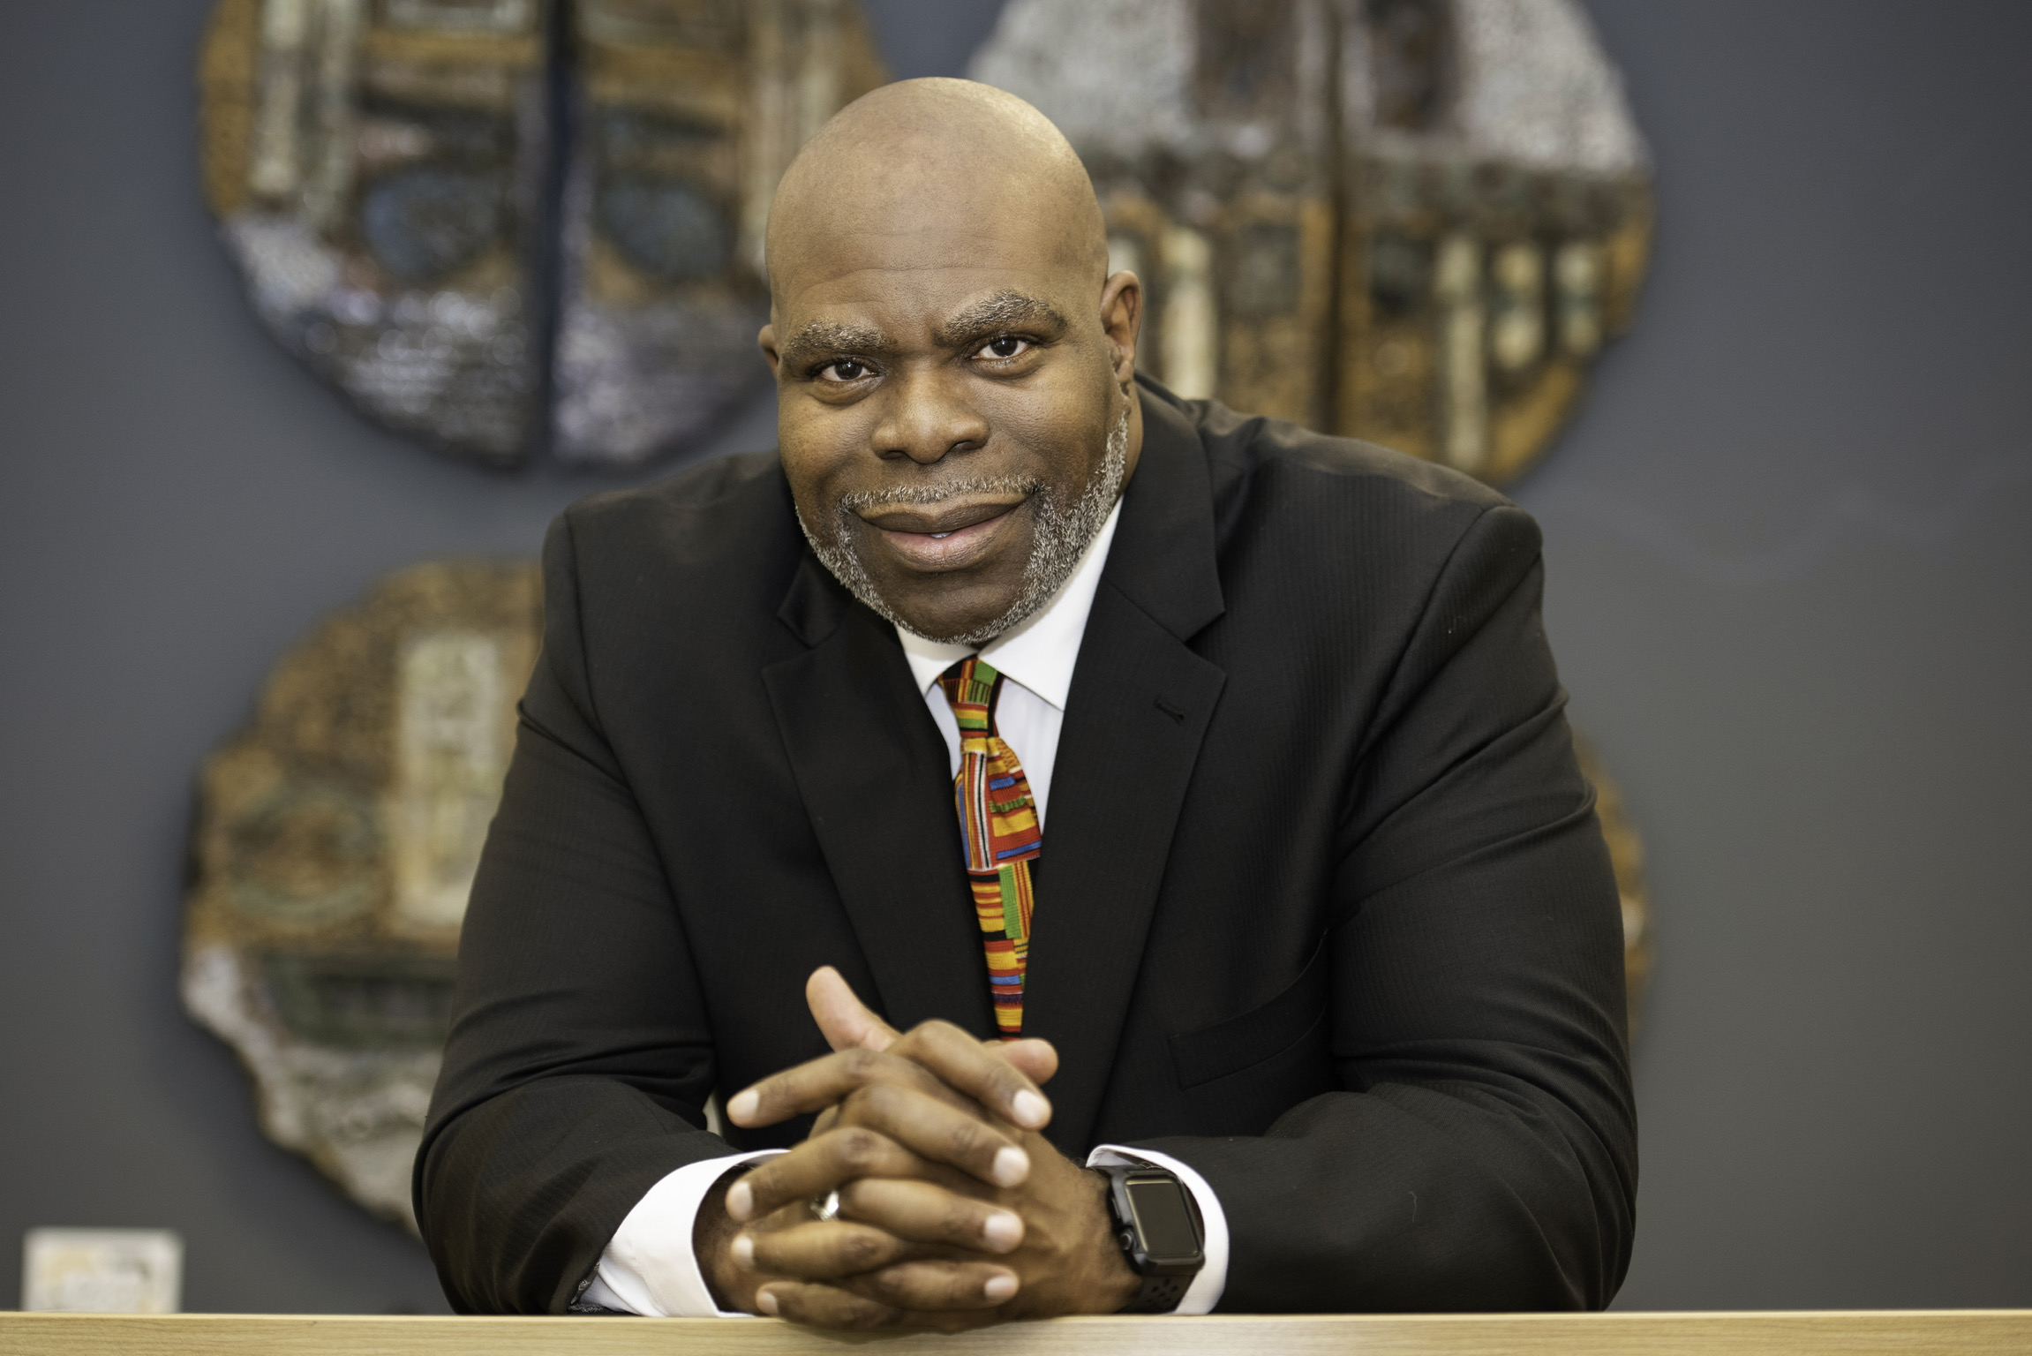
S. Kent Butler, Jr. holds a Ph.D. in Educational Psychology, with a concentration in Counseling Psychology, from the University of Connecticut. He is a Licensed Professional Counselor (LPC), Nationally Certified Counselor (NCC), and Nationally Certified School Counselor (NCSC). In February of 2020, Dr. Butler was elected President-Elect of the American Counseling Association (ACA). His presidential year is 2021 – 2022. In July of 2019, Dr. Butler was appointed Interim Chief Equity, Inclusion and Diversity Officer at the University of Central Florida. In March of 2020, he was selected as a Fellow within the National Association of Chief Diversity Officer in Higher Education’s Chief Diversity Officer Fellows Program (NADOHECDOFP). He is a 2020 – 2021 cohort (C-7) member. The professional leadership program mentors new and early career Chief Diversity Officers. Dr. Butler was also recently promoted to Professor of Counselor Education at the University of Central Florida and has served as a Faculty Fellow for Inclusive Excellence within the Office of the Provost. Dr. Butler presently serves as faculty advisor to CHI SIGMA IOTA International Honor Society (CSI), the Counselor Education Doctoral Student Organization (CEDSO), Project for Haiti Knights, and the National Association for the Advancement of Colored People (NAACP). He served as the Principal Investigator, for The High-Risk Delinquent and Dependent Child Educational Research Project: Situational Environmental Circumstances Mentoring Program (SEC), which was a partnership between the University of Central Florida and several Florida universities. This grant opportunity has transitioned into the UCF Young Knights Mentoring Project a program that supports students at Hungerford Elementary School in Eatonville, FL. Also on the national level, Dr. Butler has served the Association for Multicultural Counseling and Development (AMCD) as the 2011 – 2012 President and ACA Governing Council Representative (2015 – 2018). He is honored to be a member of AMCD’s Multicultural Counseling Competencies Revisions Committee (2014 – 2015) which produced the ACAAMCD endorsed Multicultural Social Justice Counseling Competencies (MSJCC). In April of 2016, Dr. Butler was bestowed with the prestigious ACA Fellow Award. His research and academic interests lie in the areas of Multicultural and International Counseling, Social Justice, Mentoring, Counseling work as it relates specifically to African American males, Group Counseling, School Counseling, and Multicultural Supervision.

Session #4 - Navigating Grief and Loss in Our Urban Communities

Attendees will learn to: (1). Provide an overall understanding of grief, loss, and trauma, (2). discuss the theories used to provide grief support services, and (3). Discuss creative strategies to promote healthy grieving.

Veronica Land-Davis, LCSW-C
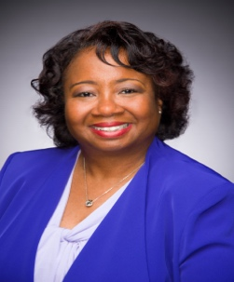
Veronica Land-Davis, a licensed certified social worker-clinical, has over thirty years of experience working with children, adults and families. Veronica has served families in roles of both a clinician and a manager in many settings such as residential treatment centers, child prevention agencies, Treatment Foster Care, Head Start, grief support centers and Home Health Care. Educated in the Baltimore City Public School system, she received her Bachelors of Science Degree in Sociology/Social Work from University of Maryland, Baltimore County. Veronica attained her Master’s Degree in Social Work from the University of Maryland School of Social Work. In 2001, she completed The Head Start-Johnson & Johnson Management Fellows Program at the John E. Anderson Graduate School of Management at UCLA. She is the 2018 recipient of the Roper Victim Academy of Maryland’s leadership award. Mrs. Land-Davis is currently the Executive Director of Roberta’s House, a family grief support center located in Baltimore City and Prince George’s county. When she is not providing services to others, she enjoys reading a good a book and a watching the Oriole’s games.

Adam Johnson, M.S., LCPC
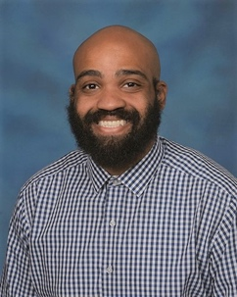
Adam Johnson, M.S., LCPC has a passion for serving children and families in Baltimore, MD. Adam earned a Bachelor’s Degree in Applied Psychology in 2012 from Coppin State University. Adam continued his education at Johns Hopkins University where he earned his Master’s Degree in Mental Health Counseling in 2016. Currently, Adam is the Family Services Program Manager at Roberta’s House, a grief counseling center located in Baltimore, MD. In his role, Adam helps individuals and families in the intake process to enroll in the various group grief counseling groups, oversees the men’s grief support group and Families Healing Together group . Before working at Roberta’s House, Adam worked numerous years as a, School Based Mental Health Counselor for various organizations in Baltimore City Public Schools. Adam provided individual, family, and group counseling. Adam also worked closely with school staff to make sure all student’s needs were meet in this role.

Session #5 - “Clinical Assessment Across Cultures: Implications for Counselor Avoidance of Myopic Clinical Evaluation”

Attendees will learn to: (1) examine the counselors’ level of empathy with clients across-cultures, (2) explore the counselors’ recognition of the worldviews of the clients, and (3) discuss the counselors’ understanding and recognition of their possible clinical myopic assessment cognitions that might have a negative impact on the therapeutic relationship.

Jake Johnson, Ph.D., LPC, LCPC, NCC
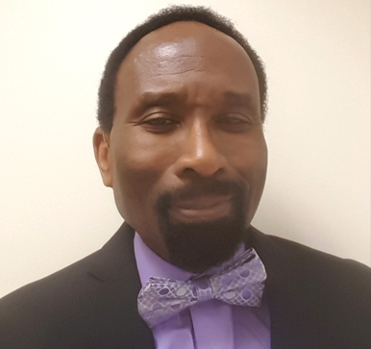
Dr. Jake A. Johnson is an Associate Professor in and past department chair of the Department of Counseling in the College of Education at Bowie State University. He completed his education at the University at Albany (SUNY), Howard University, and The George Washington University. He is a Licensed Professional Counselor, a Licensed Clinical Professional Counselor, a Nationally Certified Counselor, trainer, consultant, educator and author. He teachers graduate courses in school counseling, mental health counseling and counseling psychology. Professionally, Dr. Johnson is an active member of the American Counseling Association (ACA). In ACA, he has chaired, participated and presented in sessions and workshops on creating a healthy workplace, trauma and cognition, stress management, rage, diversity, multiculturalism, existentialism, and existential cross-cultural counseling at national and international conferences. Dr. Johnson has authored and co-authored publications on trauma, multicultural counseling/cross-cultural counseling, and is a co-author of a best-selling counseling textbook, “Cross-cultural counseling: A case book”. He is also a member of the Association for Multicultural Counseling and Development (AMCD): Past-Chair, Association Development; Co-chair, Twentieth Anniversary Committee; and Past-Chair, Twenty Fifth Anniversary. He is a Past-President of the Maryland Counseling Association (MCA), and the Maryland Association for Multicultural Counseling and Development (MAMCD). Dr. Johnson is a board member of the International Society for the Ethical Psychology and Psychiatry (ISEPP).

Session #6 - “Counseling Interventions to Support Asian Americans Facing Discrimination Related to COVID-19”

Attendees will learn to: (1). provide a historical context for Anti-Asian sentiment in the United States, (2). highlight the effects of anti-Asian attitudes and behaviors on the psychological well-being of Asian Americans, (3) explore the recent events of Anti-Asian hate crimes, (4). discuss stereotypes and prejudice faced by Asian women in the United States, (5). introduce counseling interventions for clinicians working with Asian American clients who have experienced overt discriminatory behavior.

Ricardo Phipps, Ph.D., LPC, LCPC, NCC
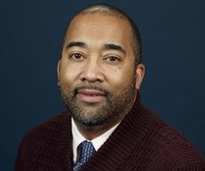
Dr. Ricardo Phipps is the Director of Clinical Training for the Master’s Counseling programs at The Chicago School of Professional Psychology-DC Campus. He began his tenure at The Chicago School as Assistant Professor of Clinical Mental Health Counseling in Fall 2019. He is licensed as a professional counselor in Maryland, Virginia, and Pennsylvania. Ricardo has a strong clinical interest in working with college/university students and in the integration of spirituality and religious themes into counseling. He is passionate about using counseling as a tool to help clients grow in their sense of meaning in life. Ricardo is proud to be a 2020-21 Maryland Counseling Association Emerging Leader, serving with the Multicultural Counseling and Development Division (MAMCD). Within MAMCD, he serves as the Membership Co-chair and is a member of the Research & Scholarship Committee.

Prem Umang Satyavolu, M.S.,NCC
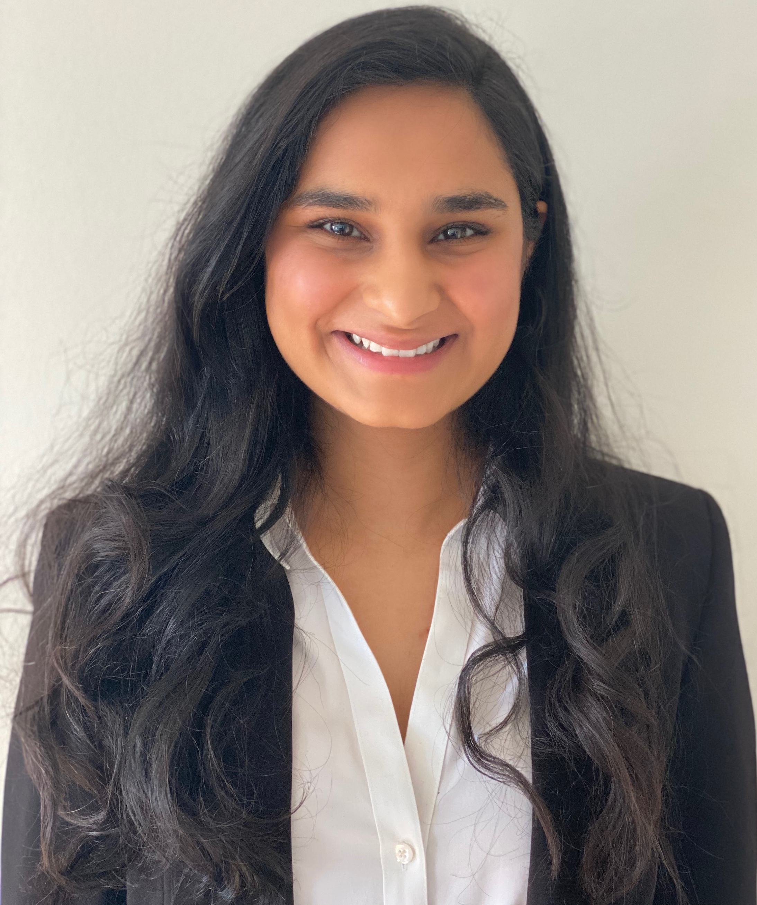
Prem Umang Satyavolu is currently the President of CSI Lambda Chapter and a Maryland Counseling Association Emerging Leader 2020-2021. She is also a Crisis Clinician at Penn Medicine Princeton Health and a Teaching and Research Assistant at Johns Hopkins University. She completed her undergraduate studies in Psychology in India where she served and advocated for underprivileged populations and women’s rights by providing educational and mental health resources. She also has an M.S. in Clinical Mental Health Counseling from Johns Hopkins University, interned at the Johns Hopkins Outpatient Center Blaustein Pain Clinic, and is a Nationally Certified Counselor. Her current research interests aim to understand the impact of emerging technologies on human behavior and the importance of creating easily accessible, frugally created, culturally sensitive resources for underserved populations.

